How to Activate/Inactivate Account (GLAT)

- Type “GLAT” into Colleague
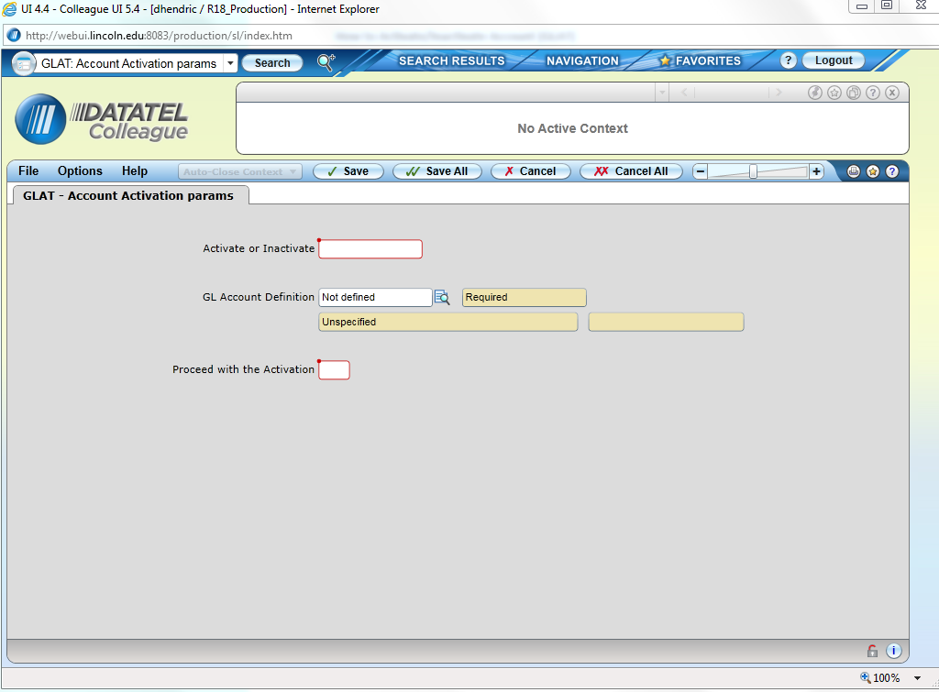
- To Activate an account enter “A” for “Activate or Inactivate” (To Inactivate type “I”) …For this example we will inactivate an account. Same process (just use “A”) to activate
  - Enter “I” in “Activate or Inactivate” box
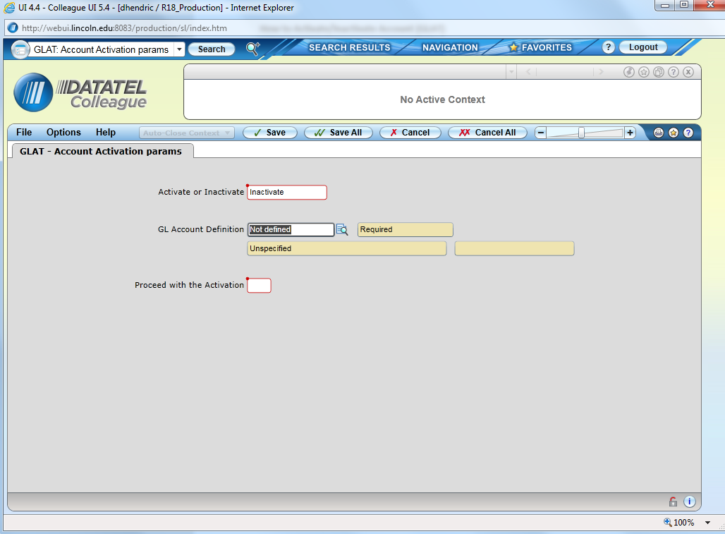
  - Click on the magnifying glass box to select the account to inactivate – Then Click on “Select List”
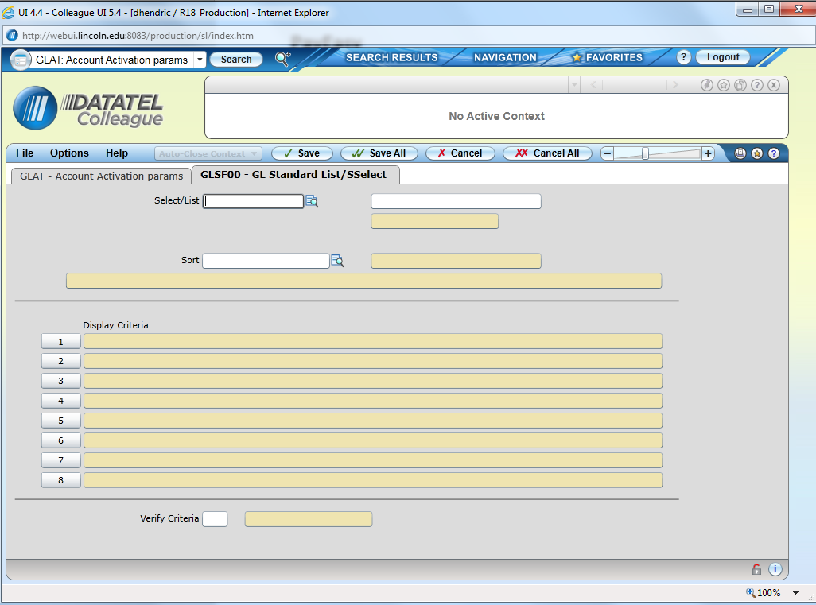

  - Identify the account to be inactivated as shown below

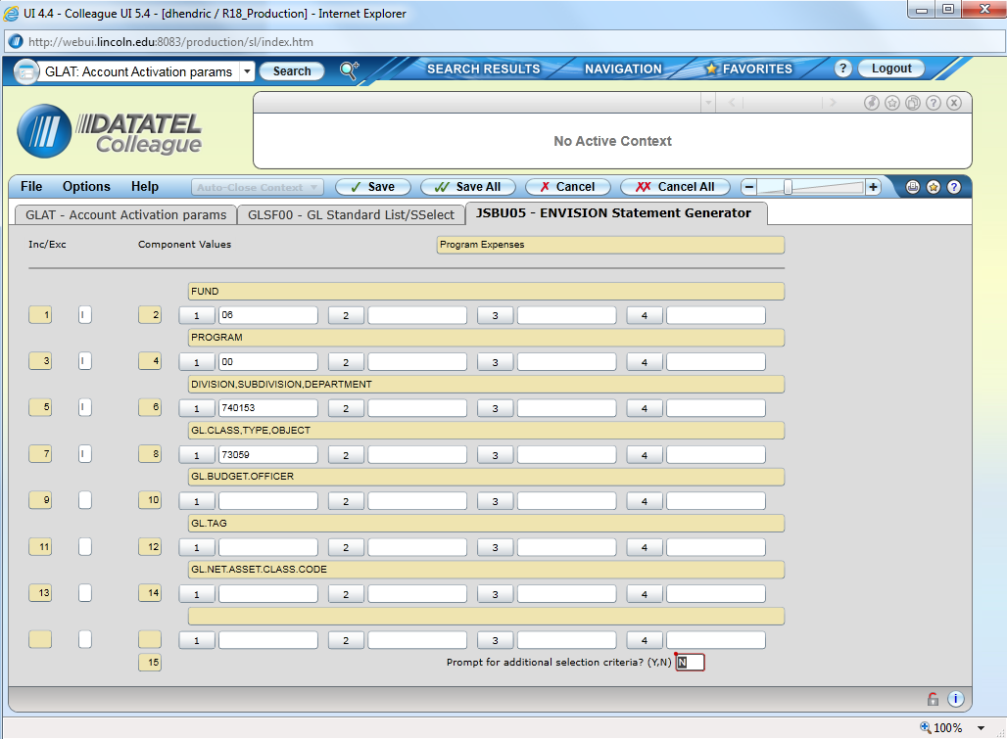
  - Select “Save All”
  - This brings you back to the main screen (shown below)
  - Enter “Y” for “Proceed with Activation” ( In this example it’s an inactivation)

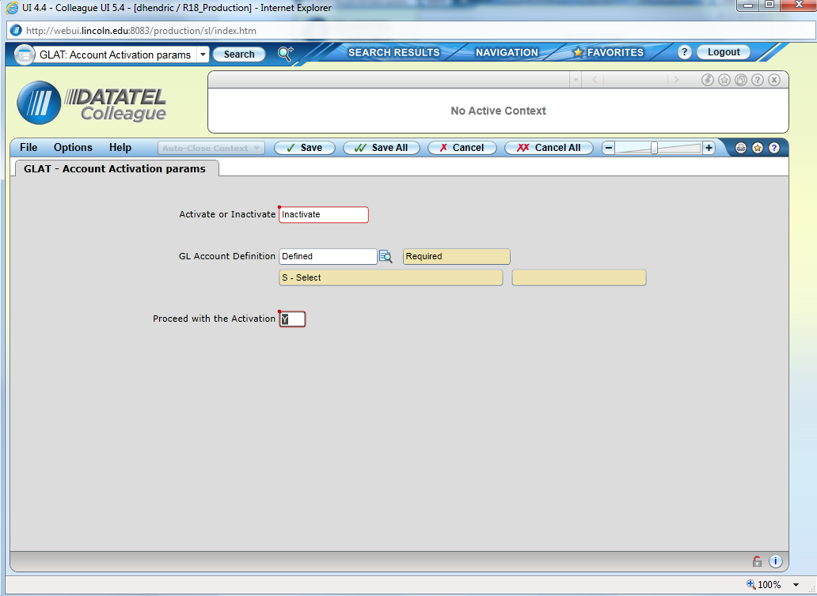
  - Select “Save All” “Hold for Output (“H”) and “N” for background mode
  - The below will appear confirming Activation/Inactivation

